**ELECTRICITY ENERGY THEFT DETECTION IN SMART GRIDS USING DEEP NEWRAL NETWORKS**

**A project report submitted in partial fulfillment of the requirement for the award of the degree of**

**BACHELOR OF TECHNOLOGY**

**In**

**COMPUTER SCIENCE & ENGINEERING**

**Of**

**JAWAHARLAL NEHRU TECHNOLOGICAL UNIVERSITY ANANATPUR, ANANTHAPURAMU.**

**By**

**ARCOT NAVEEN 202K1A0504**

**LAMBADE VENKATESH 202K1A0535**

**JUJARE RANJITH KUMAR 202K1A0527**

**D K KRIDHNA MOHAN 202K1A0515**

**M VINOD KUMAR 202K1A0536**

**MILAPURAM RAVI KIRAN 20HU1A0566**

**Under the esteemed guidance of**

**B. HUSSAIN M. Tech.**

**Associate Professor**

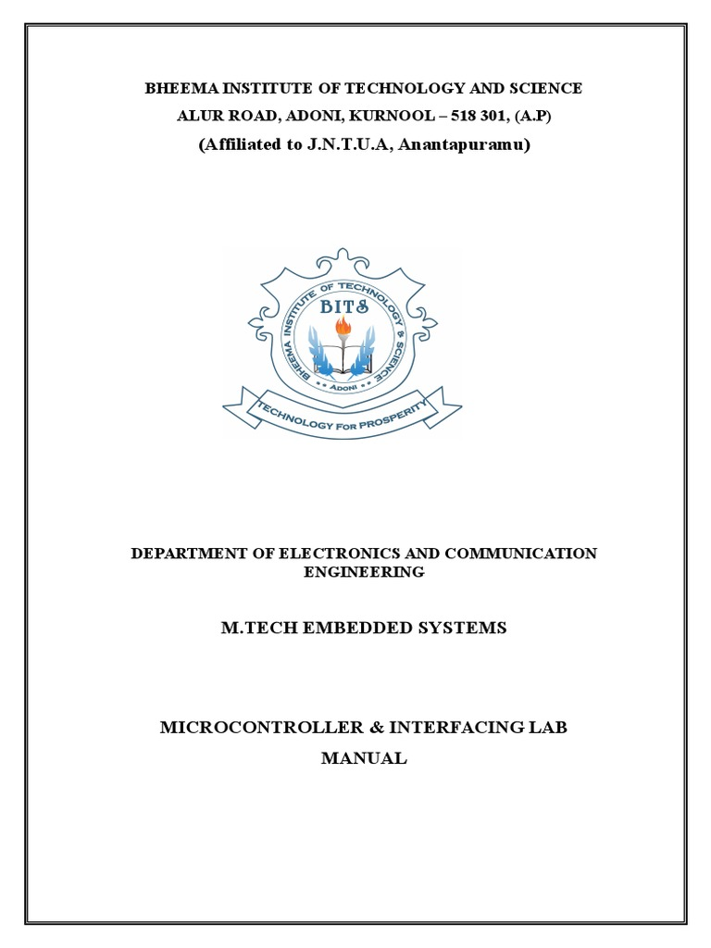

**DEPARTMENT OF COMPUTER SCIENCE & ENGINEERING**

**BHEEMA INSTITUTE OF TECHNOLOGY AND SCIENCE**

**Alur Road, Adoni-518301, Kurnool, Andhra Pradesh**

**(Affiliated to Jawaharlal Nehru Technological University Anantapur, Ananthapuramu)**

**2020-2024**

**BHEEMA INSTITUTE OF TECHNOLOGY AND SCIENCE**

**Alur Road, Adoni – 508301**

(Affiliated to Jawaharlal Nehru Technological University Anantapur, Ananthapuramu)



**DEPARTMENT OF COMPUTER SCIENCE & ENGINEERING**

**CERTIFICATE**

This is to certify that the project entitled “**ELECTRICITY ENERGY THEFT DETECTION IN SMART GRIDS USING DEEP NEURAL NETWORKS”** being submitted by **ARCOT NAVEEN (202K1A0504), LAMBADE VENKATESH (202K1A0535), JUJARE RANJITH KUMAR (202K1A0527), D K KRISHNA MOHAN (202K1A0506), M VINOD KUMAR (202K1A0536), MAILAPURAM RAVI KIRAN (20HU1A0566).** in partial fulfilment of the requirement of the award of degree of Bachelor of Technology in Computer Science & Engineering of Jawaharlal Nehru Technological University Anantapur, Ananthapuramu during the academic year 2020-2024.

B.HUSSAIN Dr. D. William Albert

**Project Guide Head of the Department**

Place: Adoni

Date:

Certified that the candidate was examined by me in the viva-voice examination held at Bheema Institute of Technology & Science, Alur Road, Adoni on _____________________.

**INTERNAL EXAMINER EXTERNALEXAMINER**

**ACKNOWLEDGEMENT**

We take this opportunity to thank all those magnanimous persons who rendered their full support to our work the pleasure, the achievement, the glory, the satisfaction, the reward, appreciation and the construction of this regular schedule spared their valuable time for us. This acknowledgement is not just a position of words but also an account of indictment. They have been guiding and source of inspiration towards the completion of this project.

We express our gratitude to **G. S. SURENDRA BABU**, principal, Bheema Institute of Technology and Science, Adoni, for giving us an opportunity to do this project work.

We also like to express our sincere gratitude and special thanks to Associate professor **Dr. D. William Albert,** Head of the Department of Computer Science and Engineering for his guidance and support towards the completion of this project.

We are thankful to our guide **B. HUSSAIN M. Tech, Associate professor**, who with his continuous efforts, unfailing interest, constant support and providing me the right infrastructure helped me in completing this project work.

We would like to thank all the faculty members of CSE department and our friends for their valuable suggestions and support which directly or indirectly helped us in mounding this project in to a comprehensive one.

We wish to express our gratitude to our parents, whose love and encouragement have a great support throughout our education.

**STUDENT NAME REGISTER NUMBER**

**ARCOT NAVEEN 202K1A0539**

**LAMBADE VENKTESH 202K1A0559**

**JUJARE RANJITH KUMAR 202K1A0561**

**D K KRISHNA MOHAN 202K1A0506**

**M VINOD KUMAR 202K1A0536**

**MILAPURAM RAVI KIRAN 20HU1A0566**

**ABSTRACT**

Electricity theft is a global problem that negatively affects both utility companies and electricity users. It destabilizes the economic development of utility companies, causes electric hazards and impacts the high cost of energy for users. The development of smart grids plays an important role in electricity theft detection since they generate massive data that includes customer consumption data which, through machine learning and deep learning techniques, can be utilized to detect electricity theft. This paper introduces the theft detection method which uses comprehensive features in time and frequency domains in a deep neural network-based classification approach. We address dataset weaknesses such as missing data and class imbalance problems through data interpolation and synthetic data generation processes. We analyze and compare the contribution of features from both time and frequency domains, run experiments in combined and reduced feature space using principal component analysis and finally incorporate minimum redundancy maximum relevance scheme for validating the most important features. We improve the electricity theft detection performance by optimizing hyper parameters using a Bayesian optimizer and we employ an adaptive moment estimation optimizer to carry out experiments using different values of key parameters to determine the optimal settings that achieve the best accuracy. Lastly, we show the competitiveness of our method in comparison with other methods evaluated on the same dataset. On validation, we obtained 97% area under the curve (AUC), which is 1% higher than the best AUC in existing works, and 91.8% accuracy, which is the second-best on the benchmark.

.

**CONTENTS**

**Chapter 1:** INTRODUCTION 1-3

1.1 Introduction 1

1.2 The Contributions of our project 2

**Chapter 2:** LITERATURE SURVEY 4-82.1 Electricity theft detection using pipeline in machine learning 4

2.2 Wide and deep convolution neural networks for electricity-theft detection to secure smart grids 4

2.3 Smart grid – The new and improved power grid: A survey 5

2.4 Efficient detection of electricity theft cyber attacks in

AMI network 5

2.5 Tackling energy theft in smart grids through data driven-analysis 6

2.6 Progress and challenges in smart grids: Distributed generation,

Smart metering energy storage and smart loads 6

2.7 Minimizing household electricity theft in Nigeria using GSM based meter. 7

2.8 Power theft detection & initiate energy meter information through SMS with auto power cut off. 7

2.9 Prototype development to detect electric theft using PIC18F452 microcontroller. 8

**Chapter 3:** SYSTEM ANALYSIS 9-17

3.1 Existing system 9

3.2 Disadvantages in Existing System 10

3.3 Proposed system 10

3.4 Advantages of Proposed system 11

3.5 Algorithms 11

3.6 System requirements 17

**Chapter 4:** SYSTEM DESIGN18-26

4.1 System Architecture 18

4.2 Detailed Design 19

4.2.1 Data Flow Diagram 19

4.2.2 Work Flow Diagram 19

4.3 UML Diagrams 20

4.3.1 Use Case Diagram 22

4.3.2 Class Diagram 23

4.3.3 Sequence Diagram 24

4.4 Flow Chat Diagram 25

4.4.1 Flow Chart: Remote User 25

4.4.2 Flow Chart: Service Provider 26

**Chapter 5:** IMPLIMENTATION27

5.1 Service Provider 27

5.2 View and Authorize Users 27

5.3 Remote User 27

**Chapter 6:** TECHNOLOGY DESCRIPTION28-43

6.1 Python Introduction 28

6.2 Introduction 30

6.3 Machine Learning 39

6.4 Packages and Versions 42

**Chapter 7:** SYSTEM STUDY AND TESTING44-48

7.1 Feasibility Study 44

7.1.1 Economic Feasibility 44

7.1.2 Technical Feasibility 44

7.1.3 Social Feasibility 45

7.2 System Testing 45

7.2.1.1 Unit Testing 45

7.2.1.2 Integration Testing 46

7.2.1.3 Functional Test 46

7.2.1.4 System Test 46

7.2.1.5 White Box Testing 47

7.2.1.6 Black Box Testing 47

7.2.1.7 Unit Testing 47

7.2.1.8 Acceptance Testing 48

**Chapter 8: OUTPUT SCREENS** 45-57

8.1 Remote User 45

8.2 Service Provider 48

**Chapter 9: CONCLUSION** 58

**Chapter 10: FUTURE ENHANCEMENT** 63

**Chapter 11: REFERENCES** 63

**LIST OF FIGURES**

|  |  |  |
| --- | --- | --- |
| **FIGURE NO.** | **FIGURE NAME** | **PAGE NO.** |
| 4.1 | Architecture Diagram | 13 |
| 4.2.1 | Block Diagram | 14 |
| 4.2.2 | Data Flow Diagram | 15 |
| 4.3.1 | Use Case Diagram | 17 |
| 4.3.2 | Class Diagram | 18 |
| 4.3.3 | Sequence Diagram | 19 |
| 4.3.4 | Activity Diagram | 20 |
| 4.4.1 | Flow Chart Of Remote User | 21 |
| 4.4.2 | Flow Chart Of Service Provider | 22 |
| 6.1.1 | Official Website Of Python | 28 |
| 6.1.2 | Download Latest Version | 29 |
| 6.1.3 | Click download on specific version | 29 |
| 6.1.4 | Different Versions Of Python | 30 |
| 6.1.5 | Installation | 31 |
| 6.1.6 | Click Install Now | 31 |
| 6.1.7 | Close After Setup | 32 |
| 6.1.8 | Command Prompt | 33 |
| 6.1.9 | Check Python Version | 33 |
| 6.1.10 | Python idle | 34 |
| 6.1.11 | Save The File | 34 |
| 6.1.12 | Example For Writing And Executing | 35 |